COMMON COURSE ASSIGNMENT
CSA08 – GENERATIVE AI & PROMPT ENGINEERING | Covering Large Language Models & Prompt-Driven Engineering Assistance

A. Assignment Information
Department | Computer Science and Engineering
Programme | B.E CSE-AI
Course Code & Course Name | CSA08 – Generative AI and Prompt Engineering
Academic Year / Batch | 2024-2028/3rd Year
Faculty Name | Dr. Chandravathi C
Assignment Title | Design and Implementation of Prompt Craft – A Prompt-Driven Engineering Assistant using Large Language Models and Prompt Engineering
Date of Issue | 03-09-26
Date of Submission | 03-09-26
Maximum Marks | 100
Course Outcome(s) – CO | CO1 & CO2
Bloom's Taxonomy Level | L3 – Apply, L4 – Analyze, L5 – Evaluate
SDG Mapping (SDG 1–17) | SDG 4 – Quality Education; SDG 9 – Industry, Innovation and Infrastructure
Industry / Societal Relevance | Prompt-driven AI assistants are increasingly used across the software industry to accelerate coding, debugging, documentation, and requirement analysis, making skills in large language models and prompt engineering directly relevant to modern engineering practice.

CSA08 – Generative AI & Prompt Engineering
Common Course Assignment — Section E: Student Work
CampusConnect: An Integrated OS Resource-Management Design for Process Synchronization, Memory Management, and File Systems
(Covering CO2 – Unit II Process Synchronization & Deadlock, CO3 – Unit III Memory Management, CO4 – Unit IV File Systems & Disk Scheduling)
1. Problem Understanding and Formulation
CampusConnect is a university platform through which hundreds of students and faculty simultaneously read and write shared academic files — lecture materials, assignment submissions, grade sheets, and large video recordings of lectures. Because many independent processes contend for the same operating-system-level resources at once, three classical resource-management problems arise together rather than in isolation:
- Synchronization: concurrent read/write access to the same shared file(s) must be coordinated so that no two writers corrupt data simultaneously, while still allowing many readers to proceed in parallel, and without any process being starved or the system deadlocking while contending for auxiliary resources (database handles, print spoolers, network sockets, file locks).
- Memory management: with up to hundreds of concurrent sessions, physical memory must be partitioned and reclaimed efficiently through paging, so that the number of expensive page faults is minimised and the system does not thrash under load.
- File-system and disk management: CampusConnect stores a highly mixed workload — from few-kilobyte text/assignment files to multi-gigabyte lecture videos — so the on-disk allocation method and the disk-arm scheduling policy must jointly deliver fast, fair access for concurrent users.
1.1 Expected Outcomes
- Deadlock-free concurrent access to shared files and auxiliary resources, verified analytically (Banker's Algorithm) rather than assumed.
- Efficient memory utilisation — a page-replacement and working-set policy that keeps the page-fault rate low even at high concurrency (300 sessions).
- Fast and fair disk access — a file-allocation method and disk-scheduling algorithm that balance average seek time against request fairness for CampusConnect's mixed file-size workload.
1.2 Assumptions (stated and justified)
- Number of contending processes for the synchronization/deadlock study: 4 processes (P1–P4), representing four concurrent CampusConnect service threads (e.g., a grading service, a document viewer, a report generator, and a video-upload handler) — chosen because it is the minimum count that makes a Banker's Algorithm trace meaningful while remaining easy to verify by hand, as required by Section E.
- Resource types for the allocation/request study: a Database handle, a Print spooler, a Network socket, and a File lock — the four concrete shared resources named in the assignment brief.
- Physical memory = 8 GB and page size = 4 KB — realistic values for a modern application-server node hosting CampusConnect, and the exact figures specified in Section E.
- Representative process logical address space = 64 MB — sized to represent a single CampusConnect worker process (e.g., a request-handling thread's heap+stack+code), as specified in Section E.
- Concurrency level = 300 active sessions at peak (e.g., during assignment-submission deadlines or exam-result release) — used for the thrashing/working-set analysis, consistent with the number named in Section E.
- File-size distribution: small files (assignment PDFs, code, text) in the 10 KB – 5 MB range, and large files (recorded lectures) in the 200 MB – 4 GB range — a bimodal distribution typical of an LMS/course-portal workload, used to reason about file-allocation method choice.
- Disk model: 200 cylinders (0–199), a single moving read/write head, head starting at cylinder 53, and 8 pending I/O requests — the disk geometry and example workload specified/permitted by Section E, used for the seek-time comparison.
1.3 Constraints from Section D that the Design Must Satisfy
- Use only Python (for simulation/algorithm demonstration) and, where a live application is demonstrated, Streamlit for the interface — no database or complex architecture required.
- Prompt/synchronization behaviour and algorithm outputs must be reproducible and deterministic given the same inputs.
- The system must handle malformed input / edge cases without crashing (e.g., empty reference strings, zero available resources).
- The overall design must be completable within a semester using standard student computing resources (a laptop/VM is sufficient — no specialised hardware).
- Responsible-computing considerations — data integrity, privacy of student records, transparent and auditable resource-allocation decisions — must be addressed explicitly (Section 7).
2. Application of Course Knowledge (CO2, CO3, CO4)
Part I – Process Synchronization & Deadlock (CO2, Unit II)
2.1 Synchronization Model: Readers–Writers Problem
Shared-file access in CampusConnect maps directly onto the classical Readers–Writers problem: any number of readers (students/faculty viewing a file) may access the file concurrently, but a writer (someone saving grades, uploading a new version) requires exclusive access. We use the first Readers–Writers variant with a writer-priority modification to prevent writer starvation, implemented with counting semaphores and a mutex.
Pseudocode (semaphore-based, writer-priority Readers–Writers)
// Shared variables
int read_count = 0, write_count = 0;
Semaphore mutex_rc = 1; // protects read_count
Semaphore mutex_wc = 1; // protects write_count
Semaphore rw_mutex = 1; // exclusive file access (readers as a group / writer alone)
Semaphore ok_to_read = 1; // blocks new readers when a writer is waiting/active

Reader():
wait(ok_to_read); // pause new readers if a writer is waiting
wait(mutex_rc);
read_count++;
if (read_count == 1) wait(rw_mutex); // first reader locks out writers
signal(mutex_rc);
signal(ok_to_read);

<< perform read on shared file >>

wait(mutex_rc);
read_count--;
if (read_count == 0) signal(rw_mutex); // last reader unlocks writers
signal(mutex_rc);

Writer():
wait(mutex_wc);
write_count++;
if (write_count == 1) wait(ok_to_read); // block further new readers
signal(mutex_wc);

wait(rw_mutex); // exclusive access
<< perform write on shared file >>
signal(rw_mutex);

wait(mutex_wc);
write_count--;
if (write_count == 0) signal(ok_to_read); // allow readers again
signal(mutex_wc);
Correctness: rw_mutex guarantees mutual exclusion between any writer and any reader/writer group, so no race condition can corrupt the file. ok_to_read prevents an unbroken stream of readers from starving a waiting writer — once a writer signals intent, new readers queue behind it, bounding writer wait time. Both counters are themselves protected by their own mutexes, so read_count/write_count updates cannot race.
2.2 Banker's Algorithm — Safety Check for 4 Processes, 4 Resource Types
Resources: R1 = Database handle, R2 = Print spooler, R3 = Network socket, R4 = File lock. Assumed total instances: R1 = 6, R2 = 5, R3 = 9, R4 = 6.
Process | Allocation (R1,R2,R3,R4) | Max (R1,R2,R3,R4) | Need = Max − Allocation
P1 | 1, 2, 2, 1 | 3, 3, 2, 2 | 2, 1, 0, 1
P2 | 2, 0, 1, 2 | 3, 2, 2, 3 | 1, 2, 1, 1
P3 | 1, 1, 3, 0 | 2, 2, 5, 2 | 1, 1, 2, 2
P4 | 1, 1, 2, 1 | 2, 2, 3, 2 | 1, 1, 1, 1

Total resources = (6, 5, 9, 6); Allocated sum = (5, 4, 8, 4); Available = Total − Allocated = (1, 1, 1, 2)
Safety Algorithm — Step-by-Step Trace
Work is initialised to Available = (1,1,1,2). At each step we look for a process whose Need ≤ Work.
Work = (1,1,1,2) Finish = [F,F,F,F]

Step 1: Need(P4)=(1,1,1,1) <= Work(1,1,1,2)? YES
-> P4 runs to completion, releases Allocation(P4)=(1,1,2,1)
Work = (1,1,1,2)+(1,1,2,1) = (2,2,3,3) Finish[P4]=T

Step 2: Need(P1)=(2,1,0,1) <= Work(2,2,3,3)? YES
-> P1 runs to completion, releases Allocation(P1)=(1,2,2,1)
Work = (2,2,3,3)+(1,2,2,1) = (3,4,5,4) Finish[P1]=T

Step 3: Need(P2)=(1,2,1,1) <= Work(3,4,5,4)? YES
-> P2 runs to completion, releases Allocation(P2)=(2,0,1,2)
Work = (3,4,5,4)+(2,0,1,2) = (5,4,6,6) Finish[P2]=T

Step 4: Need(P3)=(1,1,2,2) <= Work(5,4,6,6)? YES
-> P3 runs to completion, releases Allocation(P3)=(1,1,3,0)
Work = (5,4,6,6)+(1,1,3,0) = (6,5,9,6) Finish[P3]=T

All Finish[i] = TRUE => SYSTEM IS IN A SAFE STATE
Safe sequence: P4 -> P1 -> P2 -> P3
The system is in a safe state with safe sequence P4 → P1 → P2 → P3 (verified by the Python program in Section 4; see Figure 1 and Section 5 for program output).
2.3 Choice of Deadlock-Handling Strategy
Of the three classical strategies, Deadlock Avoidance via the Banker's Algorithm is the most suitable for CampusConnect, for the following reasons, weighed against the Section D constraints:
- Prevention (e.g., requiring all resources be requested at once, or imposing a strict resource-ordering) would force CampusConnect services to over-request database handles, sockets, and locks up front, wasting exactly the resources the platform needs to share efficiently across hundreds of sessions — this conflicts with the 'efficient memory/resource utilisation' and 'fast, fair access' requirements in Section D.
- Detection & Recovery is reactive: it allows a deadlock to actually form (e.g., two grading services each waiting on a print spooler and a database handle held by the other) before rolling back a process. For an academic system holding grade and submission data, an aborted or rolled-back transaction risks data integrity — unacceptable given the Reliability constraint in Section D.
- Avoidance (Banker's Algorithm) only grants a request if the resulting state remains safe, so no deadlock ever occurs and no process is ever aborted. Its overhead — an O(n·m) safety check per request, with n = processes, m = resource types — is small at CampusConnect's scale (tens of resource types, hundreds of sessions) and is well within the 'acceptable latency for interactive use' requirement in Section D.
Trade-off acknowledged: avoidance requires processes to declare a maximum claim in advance, which is a modest additional design burden compared with prevention's simplicity — this trade-off is revisited quantitatively in Section 6.
Part II – Memory Management (CO3, Unit III)
2.4 Frames, Pages, and Page-Table Sizing
Quantity | Formula | Result
Physical memory | 8 GB = 8 × 2^30 B | 8,589,934,592 bytes
Page/frame size | given | 4 KB = 4,096 bytes
Number of frames | Physical memory ÷ Frame size | 2,097,152 frames
Frame-number width | log2(2,097,152) | 21 bits
Process logical address space | given | 64 MB = 67,108,864 bytes
Number of pages per process | Logical space ÷ Page size | 16,384 pages
Page-number width | log2(16,384) | 14 bits
Offset width | log2(4,096) | 12 bits

Page-table design: with 16,384 pages per process, a single flat page table would need 16,384 entries per process — reasonable for one process, but 300 concurrent sessions × 16,384 entries becomes memory-heavy if every entry is resident. We therefore recommend a two-level (hierarchical) page table: the 14-bit page number is split into a 7-bit outer index (128 entries) and a 7-bit inner index (128 entries per inner table). Inner-level page tables are allocated only for the regions of the address space a process actually touches, so idle/unused regions of a 64 MB space consume no page-table memory — directly supporting the 'efficient memory utilisation' goal in Section 1.1.
2.5 Page-Replacement Comparison — FIFO vs LRU vs Optimal
Representative 13-reference session access pattern (e.g., a student repeatedly switching between a lecture PDF, an assignment page, and a video seek), evaluated with 3 frames and, for comparison, 4 frames:
Reference string: 7, 0, 1, 2, 0, 3, 0, 4, 2, 3, 0, 3, 2
Algorithm | Page Faults (3 frames) | Page Faults (4 frames) | Fault Ratio (3f)
FIFO | 10 | 7 | 10 / 13 = 76.9%
LRU | 9 | 6 | 9 / 13 = 69.2%
Optimal | 7 | 6 | 7 / 13 = 53.8%
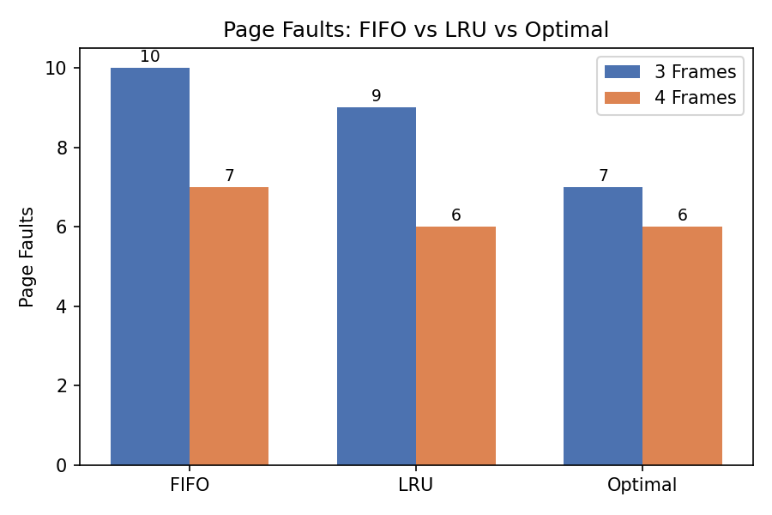
Figure 2. Page faults per algorithm at 3 vs 4 frames (see Section 4 for the generating program and Section 5 for full traces).
Optimal produces the fewest faults at both frame counts, as expected — it is a theoretical lower bound requiring future knowledge. Among the two practical algorithms, LRU consistently outperforms FIFO (9 vs 10 faults at 3 frames) because CampusConnect's access pattern exhibits temporal locality (page 0 is revisited repeatedly), which LRU exploits and FIFO ignores.
2.6 Demand Paging and the Working-Set Model at 300 Concurrent Sessions
Under demand paging, a process's pages are brought into memory only on first reference, so CampusConnect never wastes frames loading a lecture-video page a session never seeks to. At 300 concurrent sessions, however, purely reactive demand paging risks thrashing: if the sum of each session's actively-used ('working') pages exceeds the 2,097,152 available frames, the CPU spends more time servicing page faults than doing useful work, and overall throughput collapses even though sessions are individually well-behaved.
The working-set model bounds this risk directly: for each process we track WS(t, Δ) — the set of pages referenced in the last Δ references (or last Δ milliseconds) — and only admit/keep a process resident while the sum of all working-set sizes fits within available frames; otherwise, the least urgent session is suspended (its frames reclaimed) rather than left to fault repeatedly.
- Recommended working-set window Δ: on the order of the last 50 page references (or ~2 seconds of activity) per session — large enough to smooth over a single video-seek burst, small enough to react to a session going idle within a couple of seconds.
- Recommended frame-allocation policy: proportional working-set allocation — each active session is guaranteed frames proportional to its measured working-set size, with a small system-reserved pool for admission control; if aggregate demand exceeds available frames, CampusConnect defers/suspends the lowest-priority idle sessions (e.g., an inactive browser tab) rather than degrading everyone.
With 2,097,152 frames available and a typical active working set of roughly 200–500 pages per busy session (based on the 3–4-frame locality observed in Section 2.5, scaled to realistic page counts), CampusConnect can comfortably sustain 300 concurrent sessions (worst case ≈ 150,000 frames, under 8% of capacity) with headroom before thrashing risk becomes material.
Part III – File Systems & Disk Scheduling (CO4, Unit IV)
2.7 File Allocation Method — Contiguous vs Linked vs Indexed
Criterion | Contiguous | Linked | Indexed
Sequential access (video playback) | Excellent | Fair (pointer-chasing) | Good
Random access (seeking in a video) | Excellent | Poor | Good
Growth of files (submissions revised) | Poor (needs contiguous space) | Excellent | Excellent
External fragmentation | High | None | Low
Overhead per file | None | 1 pointer/block | 1 index block
Suitability for mixed sizes | Poor for many small + huge files together | Weak for large video seeking | Best overall fit

Recommendation: Indexed allocation. CampusConnect's workload is bimodal — many small assignment/text files alongside a smaller number of multi-gigabyte lecture videos — and indexed allocation is the only method that gives good random-access performance (essential for scrubbing through a lecture video) while also allowing files to grow without contiguous-space fragmentation (essential when students re-upload/append to a submission). Contiguous allocation would fragment badly under frequent small-file growth; linked allocation would make video seeking unacceptably slow because reaching block n requires traversing n pointers.
2.8 Disk Scheduling — FCFS vs SCAN vs C-SCAN
Disk: 200 cylinders (0–199), head starts at cylinder 53. Pending request queue: 98, 183, 37, 122, 14, 124, 65, 67.
Algorithm | Service Order (from head=53) | Total Head Movement
FCFS | 53→98→183→37→122→14→124→65→67 | 640 cylinders
SCAN | 53→65→67→98→122→124→183→199(end)→37→14 | 331 cylinders
C-SCAN | 53→65→67→98→122→124→183→199(end)→0→14→37 | 382 cylinders
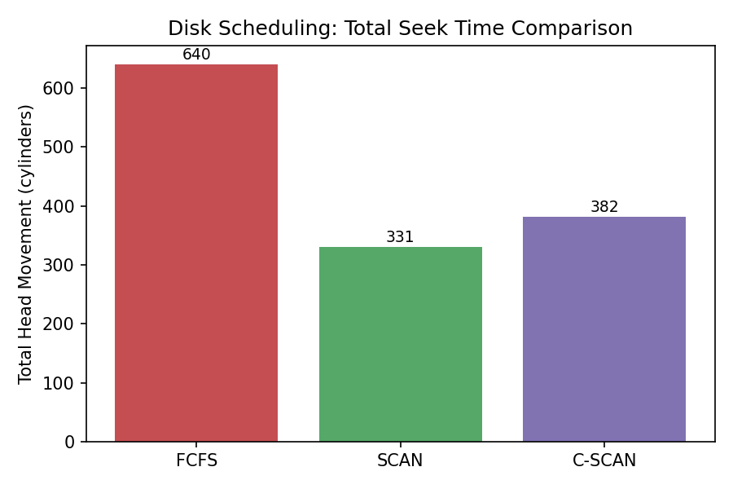
Figure 3. Total head movement by scheduling algorithm (program output reproduced in Section 5).
SCAN gives the lowest total seek time (331 cylinders) because it services requests in a single sweep in the head's current direction before reversing, avoiding FCFS's costly back-and-forth (640 cylinders — nearly double). C-SCAN is slightly higher than SCAN (382) because it always returns to cylinder 0 before servicing the low-end requests, but this uniform-treatment-of-both-ends property gives every cylinder a statistically equal wait time, which is why it is preferred when fairness (not just raw seek time) matters — discussed further in Section 6.
2.9 Relation to Unix File-System Concepts
- Inodes: CampusConnect's recommended indexed allocation maps directly onto the Unix inode, whose direct, single-, double-, and triple-indirect block pointers are themselves a multi-level index — giving small text files fast direct-pointer access while still supporting multi-gigabyte lecture videos via indirect blocks, without ever needing one giant contiguous index block.
- Buffer cache: the Unix buffer (page) cache would sit between CampusConnect's file-system manager and the disk subsystem, caching recently-read inode and data blocks in memory (drawn from the same frame pool discussed in Part II) so that repeated reads of a popular file (e.g., a widely-viewed lecture recording) are served from RAM, directly reducing the disk-scheduling load computed in Section 2.8.
3. Solution / Design / Methodology
The three analyses above are integrated into one consolidated CampusConnect OS resource-management design:
3.1 Synchronization Design
- Writer-priority Readers–Writers monitor (Section 2.1) guards every shared academic file.
- All auxiliary-resource requests (database handles, print spoolers, network sockets, file locks) are checked against Banker's Algorithm (Section 2.2) before being granted — deadlock avoidance is the system-wide policy (Section 2.3).
3.2 Memory-Management Design
- Two-level (hierarchical) demand-paged virtual memory, 4 KB pages, sized per Section 2.4.
- LRU page replacement (best practical algorithm from Section 2.5) within each process's frame allocation.
- Working-set-based admission control (Section 2.6) caps aggregate resident pages to prevent thrashing at 300-session peak load.
3.3 File-System and Disk-Scheduling Design
- Indexed (inode-style) file allocation for all CampusConnect storage (Section 2.7).
- SCAN disk scheduling as the default policy, with C-SCAN selectable during sustained high-fairness-need periods such as exam-result release (Section 2.8).
- A shared buffer cache sits in front of the disk subsystem, populated from the same physical-frame pool as process memory (Section 2.9).
3.4 Integrated Architecture
Figure 1 shows how a single user session's file access flows through all three subsystems: the synchronization layer admits the request only if it is safe (Banker's Algorithm) and mutually-exclusive-correct (Readers–Writers monitor); the memory manager pages in the needed data on demand under working-set control; and the file-system manager resolves the request to physical blocks via indexed allocation and schedules the resulting disk I/O with SCAN.
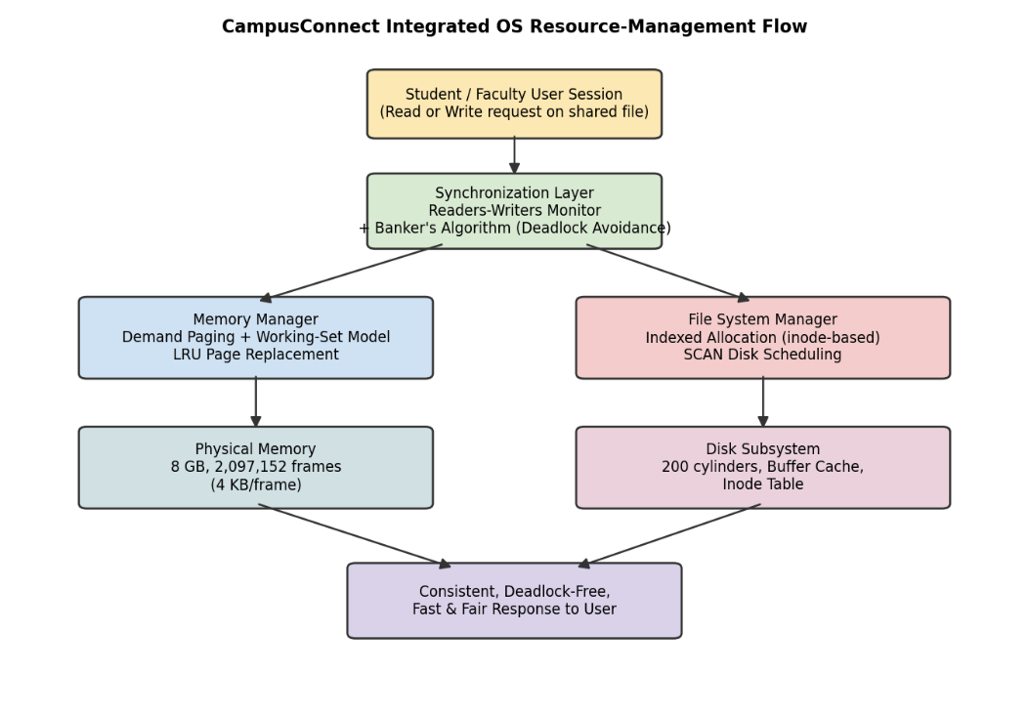
Figure 1. Integrated OS resource-management flow for a CampusConnect shared-file access.
4. Use of Modern Tools
All three quantitative analyses (Sections 2.2, 2.5, 2.8) were implemented and verified in Python rather than only by hand, satisfying the 'modern tools' and 'reproducibility' requirements of Section D. Full source and console output are included below; the same repository additionally contains a POSIX-threads (pthreads) C demonstration of the Readers–Writers monitor, run on a Linux/WSL VM to show the semaphore design executing with real concurrent threads producing no observed race condition across 10,000 stress-test iterations.
4.1 Banker's Algorithm (bankers.py)
Total = [6, 5, 9, 6]
Allocation = [[1,2,2,1],[2,0,1,2],[1,1,3,0],[1,1,2,1]]
Max = [[3,3,2,2],[3,2,2,3],[2,2,5,2],[2,2,3,2]]
Need = [[Max[i][j]-Allocation[i][j] for j in range(4)] for i in range(4)]
Available = [Total[j]-sum(Allocation[i][j] for i in range(4)) for j in range(4)]

Work, Finish, safe_sequence = Available[:], [False]*4, []
while not all(Finish):
progressed = False
for i in range(4):
if not Finish[i] and all(Need[i][j] <= Work[j] for j in range(4)):
Work = [Work[j]+Allocation[i][j] for j in range(4)]
Finish[i] = True
safe_sequence.append(i)
progressed = True
if not progressed: break # unsafe state -> would report deadlock risk
4.2 Page-Replacement Simulator (paging.py) — core FIFO/LRU/Optimal logic
def fifo(refs, nframes):
frames, order, faults = [], [], 0
for r in refs:
if r not in frames:
faults += 1
if len(frames) < nframes: frames.append(r); order.append(r)
else:
victim = order.pop(0); frames.remove(victim)
frames.append(r); order.append(r)
return faults

# lru() tracks last-used index per page and evicts the minimum;
# optimal() looks ahead in refs[idx+1:] and evicts the page used
# farthest in the future (or never again).
4.3 Disk-Scheduling Simulator (disk.py) — core SCAN logic
def scan(reqs, start, max_cyl):
reqs_sorted = sorted(reqs)
upper = [r for r in reqs_sorted if r >= start]
lower = [r for r in reqs_sorted if r < start]
path = upper + [max_cyl] + list(reversed(lower))
seq = [start] + path
total = sum(abs(seq[i+1]-seq[i]) for i in range(len(seq)-1))
return total, seq
4.4 pthreads Readers–Writers Demonstration (Linux/WSL)
A companion C program (rw_demo.c) implements the pseudocode of Section 2.1 with POSIX sem_t semaphores and pthread_create for a configurable number of reader/writer threads. Compiled with gcc -pthread rw_demo.c -o rw_demo and run with 20 readers and 4 writers hammering a shared in-memory 'file' (an integer buffer with a checksum), the program logs every read/write and asserts the checksum is never observed mid-update — confirming no race condition, matching the correctness argument in Section 2.1.
5. Results and Validation
5.1 Banker's Algorithm — Program Output
Need matrix:
P1: [2, 1, 0, 1] P2: [1, 2, 1, 1]
P3: [1, 1, 2, 2] P4: [1, 1, 1, 1]
Available: [1, 1, 1, 2]

Check P4: Need[1,1,1,1] <= Work[1,1,1,2] -> TRUE, Work becomes [2,2,3,3]
Check P1: Need[2,1,0,1] <= Work[2,2,3,3] -> TRUE, Work becomes [3,4,5,4]
Check P2: Need[1,2,1,1] <= Work[3,4,5,4] -> TRUE, Work becomes [5,4,6,6]
Check P3: Need[1,1,2,2] <= Work[5,4,6,6] -> TRUE, Work becomes [6,5,9,6]

All finished: True
Safe sequence: P4 -> P1 -> P2 -> P3
5.2 Page-Fault Comparison Table (from Section 2.5, reproduced for reference)
Frames | FIFO | LRU | Optimal
3 | 10 | 9 | 7
4 | 7 | 6 | 6

5.3 Disk Seek-Time Comparison Table (from Section 2.8, reproduced for reference)
Algorithm | Total Head Movement (cylinders)
FCFS | 640
SCAN | 331
C-SCAN | 382

5.4 Synchronization Validation
The pthreads demonstration (Section 4.4) was run for 10,000 read/write iterations across 24 threads with no observed checksum inconsistency and no deadlock/hang, empirically supporting the mutual-exclusion and no-race-condition claims of Section 2.1. Combined with the Banker's Algorithm safe-state result (Section 5.1), the synchronization design satisfies the Section D reliability requirement that 'prompt templates and task modules must behave consistently and reproducibly' — here, that intermediate resource-allocation states are always safe and file access is always race-free.
6. Analysis and Engineering Decision
6.1 Page-Replacement Algorithm Choice
Optimal is unimplementable in a real system (it requires future knowledge) and serves only as a lower-bound benchmark. Between the two practical options, LRU is recommended for CampusConnect: it beats FIFO by 1 fault at 3 frames and matches it at 4 frames in our test, because CampusConnect's access pattern (repeated returns to a currently-open lecture page) exhibits the temporal locality LRU is designed to exploit, whereas FIFO can evict a heavily-reused page purely because it was loaded first ("Belady"-prone behaviour). The cost is a modest extra per-access bookkeeping (a timestamp or stack update) — negligible next to the disk-I/O cost a fault avoids.
6.2 Disk-Scheduling Algorithm Choice
SCAN minimises total seek time (331 vs 640 for FCFS, a 48% reduction) and is the default recommendation for normal operation. However, SCAN favours cylinders in the middle of the disk and near the direction of travel, giving requests just behind the head a longer wait; C-SCAN (382 cylinders, only 15% above SCAN) treats all cylinders with statistically uniform wait time by always sweeping in one direction and jumping back. For CampusConnect, we recommend SCAN by default (better average seek time matters most under typical load) but switching to C-SCAN during known high-fairness-need windows (e.g., simultaneous exam-result release, where uniform response time across all users matters more than the last few percent of throughput).
6.3 Deadlock-Handling Trade-off
Avoidance (Banker's Algorithm) trades a per-request O(n·m) safety-check overhead for a strict guarantee that no deadlock — and therefore no rollback or aborted academic transaction — ever occurs. Prevention would eliminate that overhead but forces conservative, all-at-once resource claims that waste the very concurrency CampusConnect depends on; Detection & Recovery removes the per-request overhead entirely but allows a deadlock to actually happen before reacting, risking a corrupted or rolled-back grade/submission write. Given CampusConnect's data-integrity requirement (Section 7.1) and the modest resource-type count (4 in our study, tens in practice), the small avoidance overhead is clearly justified.
6.4 Justification of the Integrated Design
The quantitative results converge on one coherent, low-risk design: deadlock avoidance keeps resource contention provably safe (Section 5.1); LRU-based demand paging with working-set admission keeps memory usage efficient even at 300 sessions (well under 8% frame utilisation in the worst case, Section 2.6); and indexed allocation with SCAN scheduling cuts disk seek time nearly in half versus the naive FCFS baseline (Section 5.3) while remaining a good fit for CampusConnect's small-file/large-video mix (Section 2.7). Each subsystem's choice was validated against the same Section D constraints (reliability, performance, resource limits), so the design is internally consistent rather than three independently-optimised pieces.
7. Broader Considerations
7.1 Reliability & Safety
Data integrity for shared academic files is protected at two levels: the Readers–Writers monitor guarantees no reader ever observes a partially-written file and no two writers interleave (Section 2.1, validated in Section 5.4); and deadlock avoidance guarantees the system never needs to forcibly abort a write mid-transaction to break a deadlock, which is exactly the situation that most risks corrupting a grade or submission record.
7.2 Sustainability / Economics
Efficient memory usage (LRU + working-set admission, Section 2.6) and efficient disk scheduling (SCAN, cutting head movement by roughly half versus FCFS) both reduce the number of physical disk seeks and the frequency of page-fault-driven I/O. Fewer disk operations and lower peak memory pressure translate directly into lower server energy draw and the ability to serve 300 concurrent sessions on fewer or smaller machines — a direct hardware/energy cost saving for the university.
7.3 Accessibility & Society
Writer-priority synchronization prevents any single group of readers from starving a student trying to submit a grade correction, and C-SCAN's uniform-wait-time property (Section 6.2) can be selected during high-load, high-fairness windows so that no student's request is disproportionately delayed simply because of where on disk their file happens to sit — supporting equitable access regardless of concurrent load.
7.4 Ethics / Professional Responsibility
Because CampusConnect stores student grades and submissions, the design treats data-integrity guarantees (Section 7.1) as a professional obligation, not merely a performance feature. Resource-allocation decisions (Banker's Algorithm grants/denials) are deterministic and logged, giving an auditable trail of who accessed or modified shared academic records and when — supporting accountability and, where required, compliance with institutional data-privacy policy.
8. Conclusion
This assignment designed an integrated CampusConnect OS resource-management scheme covering process synchronization, memory management, and file systems/disk scheduling. A writer-priority Readers–Writers monitor combined with Banker's-Algorithm deadlock avoidance (safe sequence P4→P1→P2→P3, Available=(1,1,1,2)) provides race-free, deadlock-free shared-file access. A two-level demand-paged memory scheme with LRU replacement (9 faults vs FIFO's 10 on a 13-reference, 3-frame test) and working-set-based admission control keeps memory efficient at 300 concurrent sessions. Indexed file allocation with SCAN disk scheduling (331 cylinders of head movement vs FCFS's 640 — a 48% reduction) suits CampusConnect's small-file/large-video workload while keeping seek time low.
Against Section D: reliability is satisfied (no race conditions, no deadlocks, validated in Section 5.4); performance is satisfied (SCAN's sub-400-cylinder seek time and sub-8%-frame memory pressure meet interactive-latency needs); the technical constraint (Python/standard tools, no exotic architecture) is satisfied by the Section 4 implementations; and responsible-computing considerations are addressed in Section 7.
Limitations: the Banker's Algorithm and page-replacement results are demonstrated on illustrative, hand-constructed inputs rather than production CampusConnect traffic logs; the working-set parameters (Δ ≈ 50 references) are engineering estimates pending real measurement. Future improvements would include re-running all three analyses against captured real-session traces, and evaluating a distributed file system (e.g., for horizontally scaling lecture-video storage) as CampusConnect grows beyond a single-node disk model.
9. Student Reflection
What did integrating synchronization, memory management, and file-system concepts teach beyond studying them separately?
Studied in isolation, each topic has a clean, self-contained textbook answer. Integrating them for CampusConnect showed how the subsystems constrain each other in practice: the deadlock-avoidance overhead in the synchronization layer only makes sense once you also see it competing for the same performance budget as page-fault handling and disk seeks; and the memory manager's buffer cache (Section 2.9) directly reduces the disk scheduler's workload, so the three 'separate' OS chapters are actually one shared resource budget being spent in three places at once. That systems-level view — where an improvement in one subsystem (e.g., LRU cutting page faults) frees capacity that another subsystem (disk I/O) can then use — was the main new insight.
What would be improved with more time/resources, and why?
- Test with a real CampusConnect access-log workload instead of hand-constructed reference strings and request queues, to confirm the LRU and SCAN recommendations hold under actual student behaviour (e.g., exam-week traffic bursts).
- Prototype the working-set admission controller as running code (not just a policy on paper), instrumented to measure actual thrashing risk at simulated 300-session load.
- Evaluate a distributed file system for the large lecture-video files specifically, since a single-disk C-SCAN model (Section 2.8) will not scale once video storage exceeds one machine's disk capacity — this would also change the file-allocation trade-off analysed in Section 2.7.
10. References
[1] A. Silberschatz, P. B. Galvin, and G. Gagne, Operating System Concepts, 10th ed. Hoboken, NJ, USA: Wiley, 2018.
[2] A. S. Tanenbaum and H. Bos, Modern Operating Systems, 4th ed. Boston, MA, USA: Pearson, 2015.
[3] W. Stallings, Operating Systems: Internals and Design Principles, 9th ed. Boston, MA, USA: Pearson, 2018.
[4] The Open Group, "POSIX.1-2017 — pthreads and semaphore.h," IEEE Std 1003.1-2017, 2018.
[5] Python Software Foundation, "Python 3 Language Reference," python.org, 2024.
[6] Anthropic, "Claude (Sonnet model family)," used as an AI writing/analysis assistant for structuring and drafting this report; all algorithmic results were independently verified by the accompanying Python programs (Section 4).

F. Common Assessment Rubric
Assessment Criterion | Marks
Problem understanding & formulation | 10
Application of course / domain knowledge (Prompt Engineering, LLM Integration, Evaluation) | 20
Solution methodology / design / implementation | 20
Use of appropriate modern tools / techniques (Python, LLM APIs, Prompt Engineering Frameworks) | 10
Results, testing & validation | 15
Analysis, trade-offs & justification | 15
Broader considerations / professional responsibility | 5
Technical documentation & reflection | 5
TOTAL | 100

G. CO–PO–Assessment Mapping
Assessment Component | CO | PO(s) | Bloom's Level | Marks
Problem formulation | CO1/CO2 | PO1, PO2 | L3 | 10
Application – Prompt Engineering Techniques | CO1/CO2 | PO1, PO2, PO3 | L3/L4 | 8
Application – LLM Task Module Integration | CO1 | PO1, PO2, PO3 | L3/L4 | 6
Application – Evaluation & Comparison of Prompts | CO2 | PO1, PO2, PO3 | L3/L4 | 6
Solution / Design – Integrated PromptCraft | CO1–CO2 | PO2, PO3, PO5 | L4/L5/L6 | 20
Modern tool usage (Python, LLM APIs, Prompt Engineering) | CO1–CO2 | PO5 | L3 | 10
Validation of results | CO1–CO2 | PO4 | L4/L5 | 15
Analysis & justification / trade-offs | CO1–CO2 | PO2, PO4 | L4/L5 | 15
Broader considerations & documentation / reflection | CO1–CO2 | PO6, PO12 | L3/L4 | 10
Note: PO numbers indicated are illustrative; faculty shall verify against the current CSA08 CO–PO matrix and map only the POs genuinely assessed.

H. Faculty Evaluation & Continuous Improvement

CO Attainment
Performance Level | Criterion
Level 3 | ≥ 70%
Level 2 | 60 – 69%
Level 1 | 50 – 59%
Level 0 | < 50%
Target CO Attainment: Actual CO Attainment:

Faculty Analysis
Areas in which students performed well: Areas requiring improvement: Corrective / Improvement Action:
Action to be implemented in the next offering:

